“HR Data Analysis”

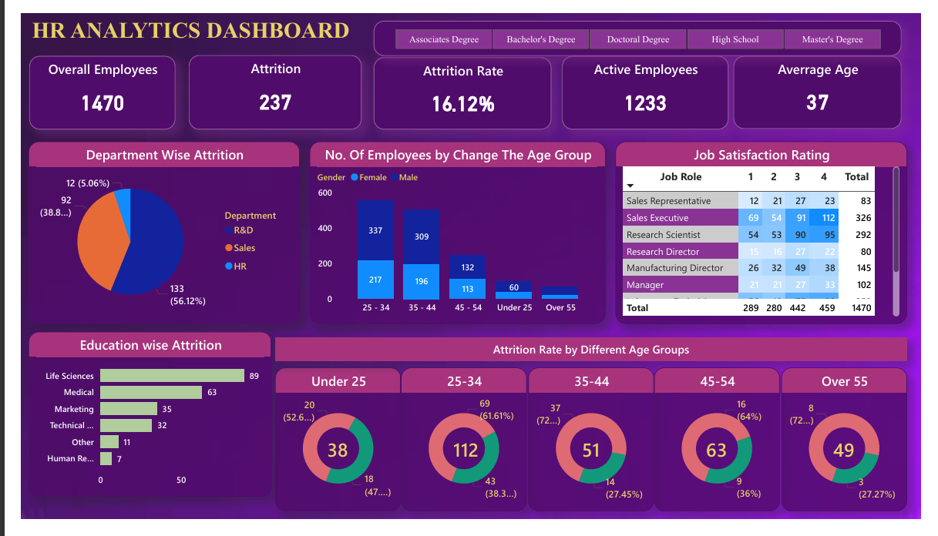

HR Data Analysis

1.Project Overview: This project is designed to analyze employee attrition patterns and workforce demographics using data from 1,470 employees. The objective is to help HR teams identify key factors driving employee turnover and enable data-driven retention strategies to improve organizational stability and performance.
2. Dataset Summary
- Rows: 1470
-Columns: 41
- Key Features:
Attrition, Business Travel, CF_age band, CF_attrition label, Department, Education Field, emp no, Employee Number, Gender, Job Role, Marital Status, Over Time, Over18, Training Times Last Year, Age, CF_current Employee, Daily Rate, Distance From Home, Education, Employee Count, Environment Satisfaction, Hourly Rate, Job Involvement, Job Level, Job Satisfaction, Monthly Income, Monthly Rate, Num Companies Worked, Percent Salary Hike, Performance Rating, Relationship Satisfaction, Standard Hours, Stock Option Level,
Total Working Years, Work Life Balance, Years At Company, Years In Current Role, Years Since Last Promotion, Years With Curr Manager
- Missing Data: In this dataset has no any missing value.

Data Analysis using SQL + Python + Excel + Power Bi
- Exploratory Data Analysis (EDA) using Python
We began with data preparation and cleaning in Python:
● Data Loading: Imported the dataset using pandas.
● Initial Exploration: Used df.info() to check structure or Data types and .describe() for summary statistics.
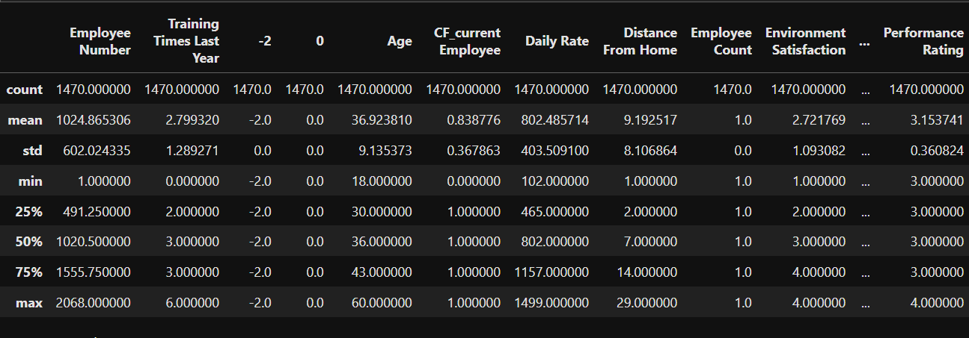

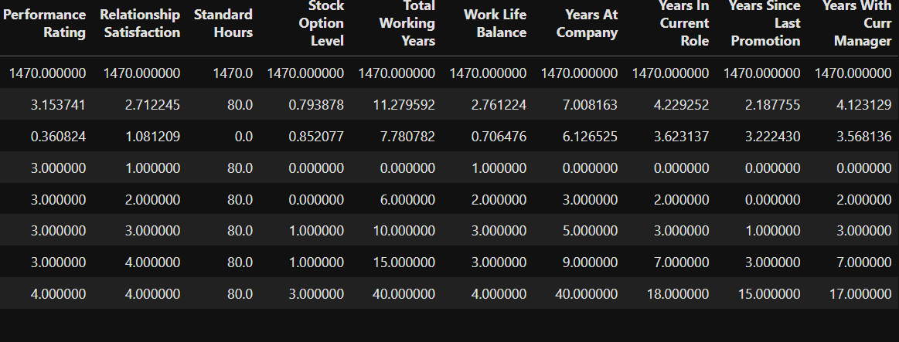

4.KPI’s Report:
- Total Employees: The company has a total workforce of 1,470 employee
- Attrition Count: A total of 237 employees has left the company.
- Average Age: The average age of employees is 36.92 years (~37 years).
- Active Employees: Currently, 1,233 employees are actively working in the organization.
- Attrition Rate: The overall employee attrition rate stands at 16.12%.
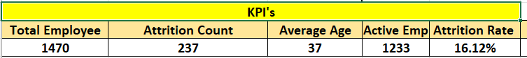

4.Deep Drive Analysis:
Employees Gender Wise:
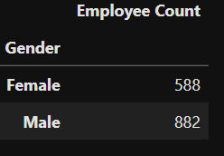
- The company has 588 female and 882 male employees, indicating a relatively balanced workforce, though male employees represent a higher proportion of the total staff.

.

- Total Employees in various Department Gender Wise
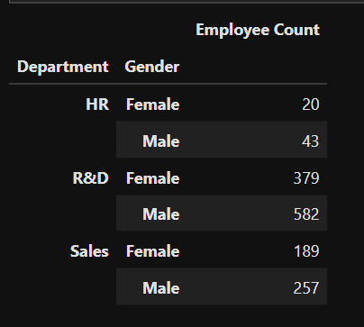
- The HR department has 20 female and 43 male employees, while the R&D department consists of 379 female and 582 male employees. Similarly, the Sales department includes 189 female and 257 male employees, indicating a higher male representation across all departments.

- Total Employees in various Education Field Gender Wise:
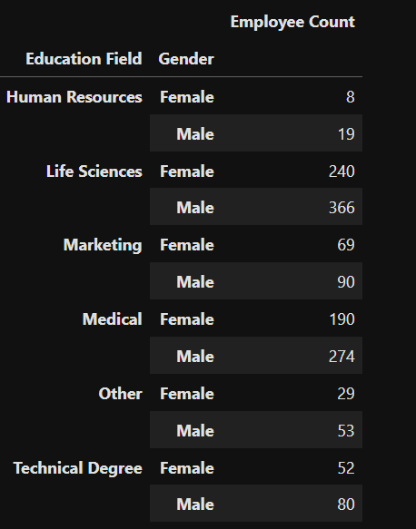
- Most of the male emp (366 emp.) whose Education Field is life Science. And most of the Female emp (240 emp) Whose Education field Life science.

  - Attrition

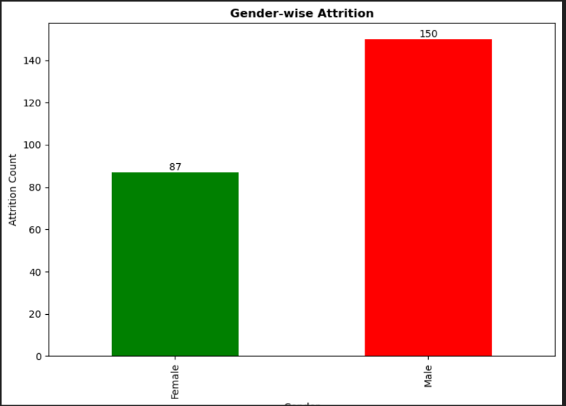
- Gender Wise Attrition:
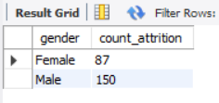
- We Observed that most of attrition by Male Emp. (150).
- Where the attrition by the male
category is 150 and Female category are 87.

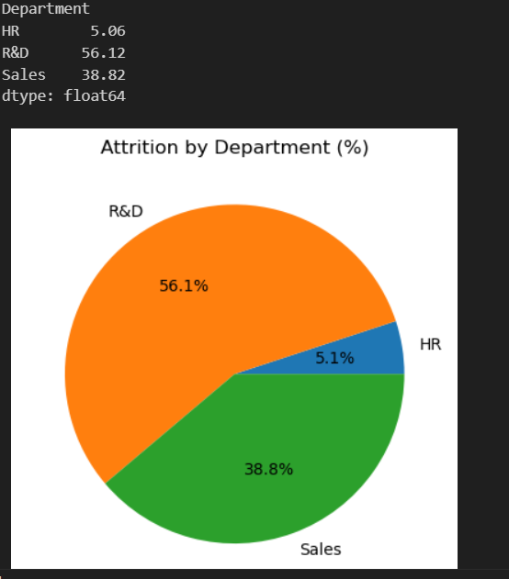
Attrition count by Department:
- Most the attrition in the dept of Research and Development (56.1%) And then Sales (38.8%) and HR Dept (5.1%).
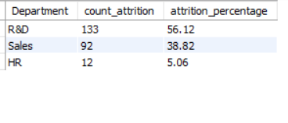

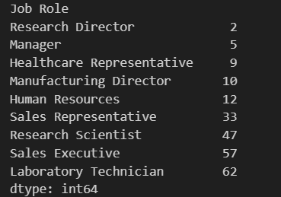
- Attrition Count by Job Role:
  - Most attrition occurs in the roles of Laboratory Technician (62 employees), followed by Sales Executive (57 employees), Research Scientist (47 employees), and Sales Representative (33 employees), indicating these positions experience the highest employee turnover.

- Attrition By Age Band:
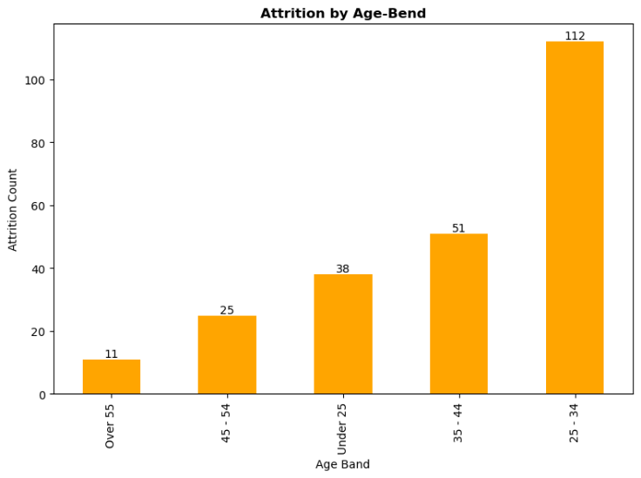
- The highest attrition is observed in the 25–34 age group (112 employees), followed by 35–44 (51 employees) and under 25 (38 employees), indicating that early to mid-career professionals are more likely to leave the organization.

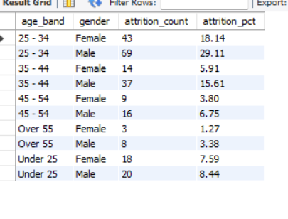

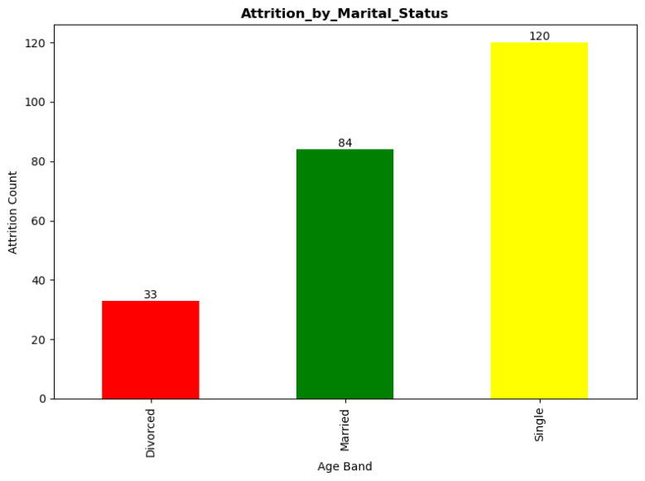
- Attrition By Marital Status:
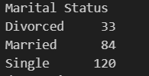

- Employees with Single marital status (120 employees) show the highest attrition, indicating that unmarried employees are leaving the organization more frequently than others.

Job Satisfaction

- Average Job Satisfaction:
- The overall average job satisfaction score is 2.73 out of 4, indicating a moderate level of employee satisfaction across the organization.

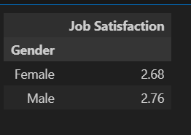
- Average Job Satisfaction Gender wise:
- The average job satisfaction score for females is 2.68, while for males it is 2.76, indicating that male employees report slightly higher satisfaction levels compared to female employees.

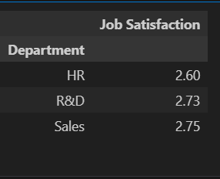
- Average Job Satisfaction Department wise:
- The average job satisfaction score is 2.68 in the HR department, 2.73 in R&D, and 2.75 in Sales. This indicates that Sales employees report the highest satisfaction levels, while HR shows comparatively lower satisfaction among the three departments.

- Average Job Satisfication by job role:

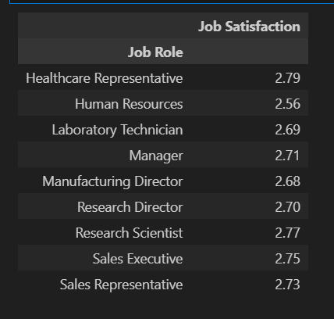
- Job satisfaction is relatively consistent across all job roles, ranging between 2.56 and 2.79, indicating no major dissatisfaction gap. However, Human Resources has the lowest satisfaction score, which may require management attention to prevent potential attrition risk.

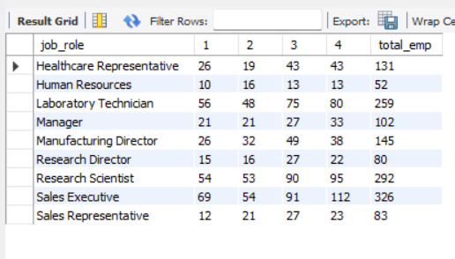


- Power Bi Dashboard:

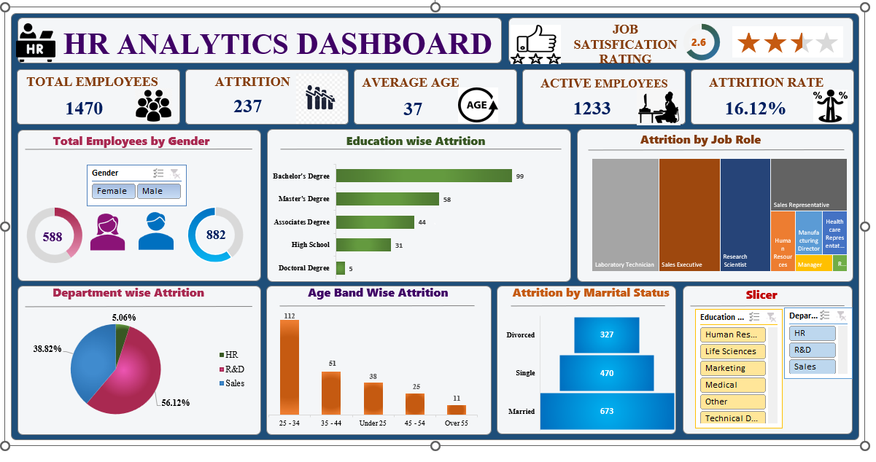
- Excel Dashboard:

- Strategic Recommendation:
- Focus on retaining employees in high-attrition roles and those in the early stages of their careers.
- Provide clear career growth opportunities and internal promotion pathways.
- Improve employee engagement, especially for single and mid-level employees.
- Regularly track job satisfaction across departments to identify and resolve issues early.
- Use data and predictive analysis to plan workforce retention strategies more effectively.

Thank you & Happy Learning!

Author’s Name:- Bipin Chandra Arya

